Ques 1 : School Results Application
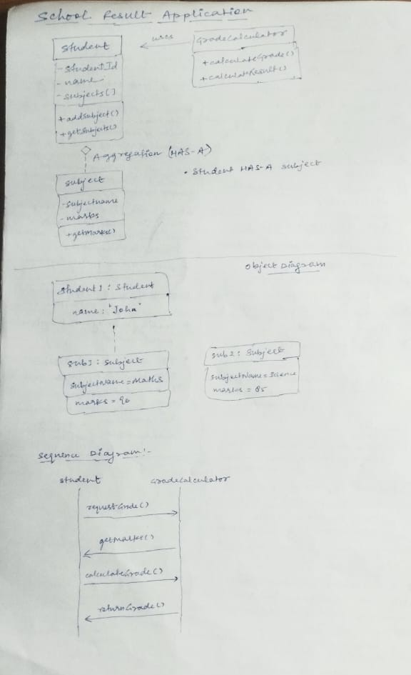
QUES 2: Grocery Store Bill Generation Application
